Edited report by Cllr Michael John Cockerill Referring to Draining and Flooding Issues
Wooldale Drive , Arndale Way, Church Cliff Drive and Site HA21 Filey.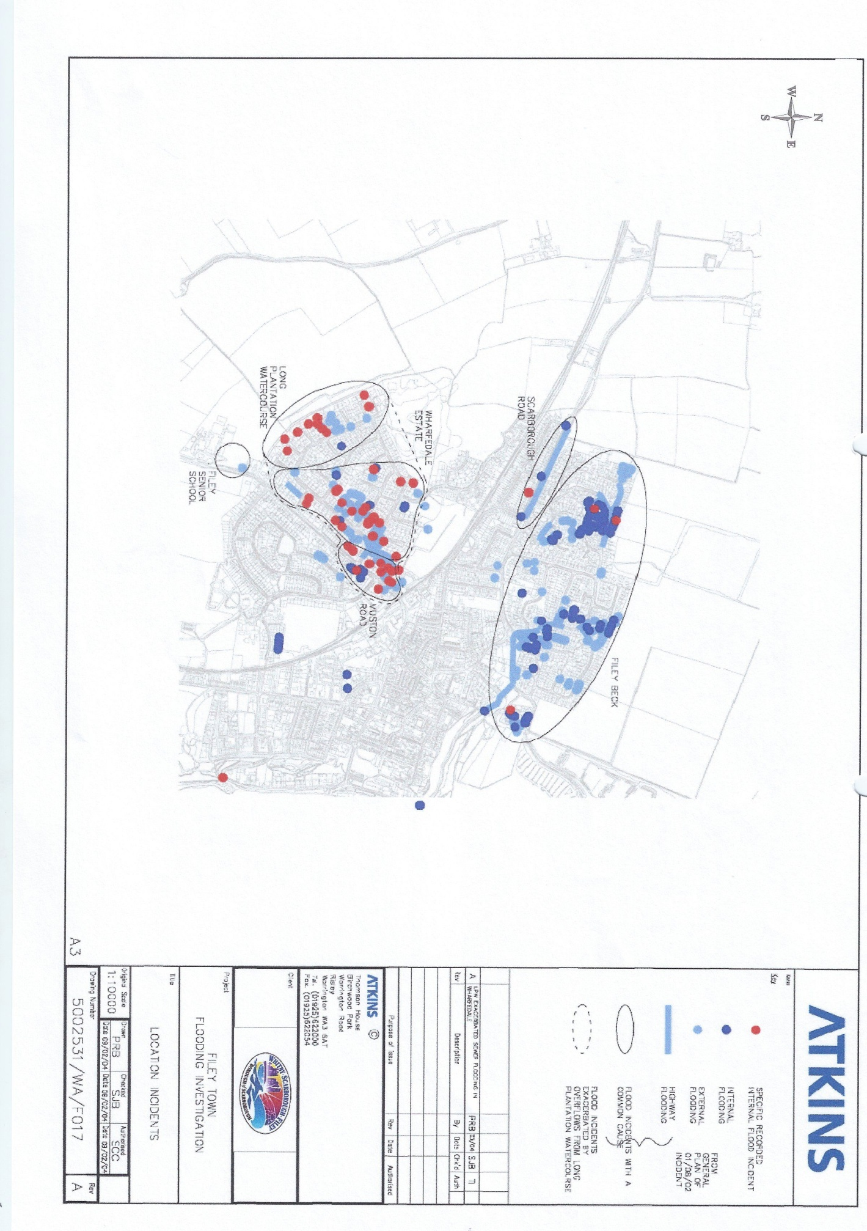

7. In justification of my contention, I raise the fact that a report published in 2004 stated that the existing system was inadequate. SBC Document Pack plus Extract in Appendix A, Item 1. Page vii, Executive Summary in Paragraph 1.4 Other Finding. The report, “The Filey Town Flood Investigation Report”, was prepared by consultants, W A Atkins, engaged by the Borough Council and funded by DEFRA.

8. In 2006 the Northeast Yorkshire Strategic Flood Risk Assessment was published having been undertaken by independent consultants, Ove Arup. SBC Document Pack. This assessment covered the whole of Scarborough Borough and Ryedale District. The report also covers the area administered by the North York Moors National Park Authority.

9. Regarding Filey the report shows, in Figure 11.12, that the whole of Filey, together with the surrounding agricultural land, is a Drainage Sensitive Area. Extract in Appendix ‘B’, Item 1.

10. Specific issues relating to Filey are laid out in Section 11.5 of the report. Section 11.5.2, Previous Flood Events and their Extents, the report states -“The Filey Town Flood Investigation Report attributes the flood events in Filey to a number of interacting problems, some relating to the watercourses and drainage systems, and others to the sewer system. The report suggests that the common factor in the majority of the flood problems is that the existing drainage systems are under capacity to deal with flood events. The Long Plantation Watercourse Flood Alleviation Scheme Report ( a further report by W S Atkins into part of the drainage system for Filey ) also provides details of several recent flood events, with particular impact on the western side of Filey. The number and general location of properties affected are included. This report attributes the flooding to insufficient channel capacity along sections of the Long Plantation Watercourse.” Extract in Appendix ‘B’, Item 2.

11. Section 11.5.3 Flood Risk Zones in and around the settlement, I quote. “Figure 11.11, which displays the existing flood risk situation in Filey, shows that a number of properties close to the coast fall within the predicted extent of Flood Zones 2 and 3. The figure also shows that other areas of Filey have experienced either overland flow flooding or sewer flooding in the past but are located within Flood Zone 1 of the Environment Agency maps. The settlement lies within a zone of potential groundwater and overland flow flood risk. The settlement lies within a zone of potential groundwater and overland flow flood risk (Zone B, see Section 6.3)”. Extract in Appendix ‘B’, Item 2.

12. Continuing, in Sub Section 11.5.3.1 Floodplain Delineation. The report states “Flood Zones 1,2 and 3 are all present within the settlement. The majority of Filey is classed as Flood Zone 1, however as explained above (Section 6.2.2), a significant amount of flooding has occurred within the settlement. Historic and hydraulically modelled flood extents have been included in Figure 11.11. For the purposes of Land use planning and development control these flood extents should be accorded the same status a Flood Zone 3. All currently developed areas within this zone may be accorded 3A(i) status, while all others should be accorded Zone 3C status”. Extract in Appendix ‘B’, Item 3.

13. Section 11.5.6 Drainage Sensitivity Catchments. “As explained in the sections above, much of the flood risk within Filey s due to issues surrounding the capacity of the existing drainage systems. Any increase in the amount of water entering these drainage systems may increase the degree of flood risk elsewhere in the settlement. These Drainage Sensitive Catchments may be particularly sensitive to potential climate change impacts”. Extract in Appendix ‘B’, Item 3.

14. Section 11.5.7 refers to Existing Recommendations Regarding New Development. ”It is recommended within the Filey Town Flooding Investigation Report that no further new developments take place in the areas identified as being at risk of flooding, or that have been subject to previous flooding, until alleviatory measures have taken place”. Extract in Appendix ‘B’, Item 3.

15. Section 11.5.8 Guidance on Land Use Planning and Flood Risk includes the statement “Development on the potential sites for flood storage areas upstream of Filey should be avoided, in order to ensure that potential for future flood alleviation work is not compromised”. Extract in Appendix ‘B’, Item 4.

16. I now need to give you some background information

17. If you look at an aerial view of Filey, Appendix C Item 1, and imagine the scene without any development, no houses, no roads just the land, you will see that there are a number of valleys that lead to the sea. Filey Bay has five major valleys that convey rain falling on the land to the sea. Indeed, it is considered that the name of Filey is derived from this fact. Fivelac meaning 5 watercourses. I will mainly concentrate on the two valleys that serve the built up part of the town, Martin’s Ravine to the South and Church Ravine to the North. The one most appropriate to this appeal is Martin’s Ravine

18. This natural drainage system evolved over many years and, we assume, worked well. Development took place to the immediate South of Church Ravine and later, mainly in the nineteenth century, further South in the direction of Martin’s Ravine. Developments in other areas took place later in the nineteenth and early twentieth centuries to the North West and West. Later in the middle of the last century further major developments were built and there has been regular development up to the present day. The drainage system existing in Filey for handling surface and foul water has evolved as the town has grown.

19. Much of the earlier part, dating from Victorian times, is a combined foul and surface water system. Additions from later housing developments are separate at their source but the pipes eventually join the combined part of the system.

20. Understanding this combined nature of the system is crucial to my subsequent comments together with the fact that any additional water the present system is asked to handle is likely to increase the instances of flooding and reduce the time it takes for flooding to take place.

21. The topography of the Filey area also needs to be understood, together with the layout of the sewer system.

22. If I may use the example of the Parish Field estate (see aerial image Appendix C, item 1, prior to its development in the late 1960’s and early 1970’s this was Greenfield land, much of which had little agricultural use. The land had a stream running through it that eventually entered the culvert that runs under Church Ravine and empty into the sea.

23. The land to the North was higher and used for agriculture. Rain from the agricultural land would drain through ditches to the stream and the sea.

24. The development interrupted this combination of natural and ditch drainage. The planning guidelines did not require an alternative drainage system to be constructed to handle this run off from the agricultural land. In fact, at the rear of Wooldale Drive, where a natural collection bowl collects a great deal of the run off a ditch was constructed and 3 small pipes were laid under domestic driveways and connected to the new drainage system in the development. Who authorised these connections has been lost in time as Yorkshire Water are not required to allow run off to enter their system. The Yorkshire Water system is designed and constructed for foul and surface water from the respective developments only.

25. Planning regulations and guidelines have continually given inadequate consideration to the issue of what to do with run off from adjacent agricultural land. Filey has suffered from this omission. That, I believe, is the major cause of Filey’s problems.

26. The Wooldale Drive area has seen a number of instances where the run off has overwhelmed the ditch, due to an insufficient flow of water through the small pipes. Up to November 2000 flooding occurred in Wooldale Drive on average at least once every ten years but since then the frequency of flooding has increased.

27. The existing drainage system is complex, it has evolved over the years and parts are being asked to operate at levels far above their capacity.

